Holy Trinity Church, Attleborough, Nuneaton
P/T Missional Family Worker Job Description and Terms and Conditions

Job Title: Missional Family Worker
Responsible to: Holy Trinity, Attleborough PCC
Hours: 16 hours per week.
This role will require working flexible hours/days across the week, including weekend and evenings. Hours can be spread across a number of weeks where necessary.
Salary: £15-17 per hour depending on qualifications and experience. Initially fixed for 3 years, with extension possible for a further 2.
Background to Post
We are an evangelical church with a big passion for Jesus and our area. We do have some families who have become part of the church but there is so much more to do. This parish has many children and there are many needs within a mile or so of the church. We have good links with our local primary schools and Oakwood Special Schools which can be built on. The parish is large, around 15000 and growing rapidly with another 1500 houses being built locally. Part of the parish is affluent, but not the area nearest the church.

We have recently begun a weekly After School Family Club called Family Fun – it’s been slow getting going but we are encouraged by the team of volunteers and the sense of family and community that there is already. We believe that there is huge potential for this to grow and become a new worshipping community. We have had a Toddler group for many years but since the pandemic we’ve been very small and few on leaders too. Is there a way we could give this a new lease of life? We also have a very busy Foodbank that is seeing more and more families attend – could this be another link?

Key Tasks:
This is a pioneer role, going out to make new relationships with families and young people. Our strap line is Connecting people to Jesus and to each other, and the role of the Family Worker will be to help us a church to make this happen.
The main aim is to increase the number of families and young people who are weekly coming into contact with the church and see them come to know Jesus and recognise their gifts, purpose and place in the world. We have a vision for community and family. We are excited at the possibilities!
- Develop relationships with families in the existing parish, but also in one or more of the new areas of housing being built in the parish and on the edge of it.
- Build community in and outside of the church.
- Find new and exciting ways to develop new forms of worship, giving children, young people and their families an opportunity to learn about Jesus, explore the Bible and space to encounter the transformative love of Jesus through the Holy Spirit. Grow an all age army of disciples.
- Help an existing team to develop our After School Family Club, Family Fun, by bringing in fresh ideas to enable us to reach and engage with local families.
- Develop the Toddler Group to reach out to more local families.
- Give a dedicated Sunday morning each month to make links with families and deliver children’s work.
- Support the spiritual and numerical growth of the Family and Children’s Leaders Team (including Junior Leaders) through regular meetings of volunteers for prayer, mutual support, training and development of their work.
- Work with the vicar to continue to develop links with our local primary schools, including delivering assemblies, lessons and church visits.

General duties
- To maintain good contact lists and accurate information on the church website, Facebook and Twitter.
- To provide reports of work as requested.
- To continue personal development through reading, appropriate training events and suitable courses of study.
- To undertake any other duties that may reasonably be required of this post holder.

It is a great time to join us and help to lead us forwards into all God has for us and the families and young people we want to reach! A small group of us have been prayer walking our area each week believing that the Holy Spirit is on the move. Could God be calling you to work at Holy Trinity?
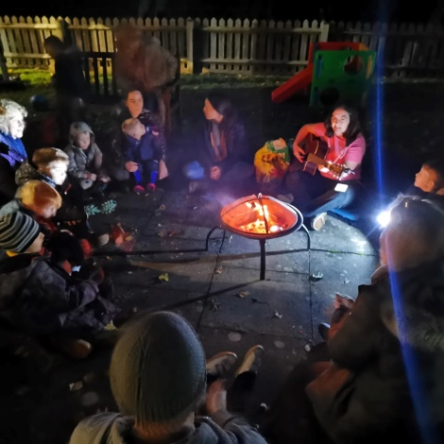
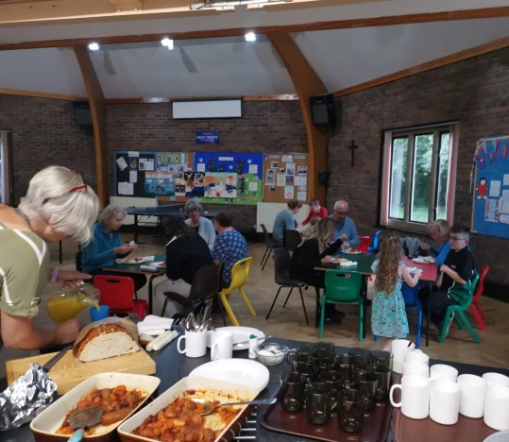
Find us on Facebook and https://holytrinityattleborough.weebly.com

Terms and Conditions

Management: The family worker will be directly accountable to the Vicar on a day-to-day basis. In the absence of a vicar a member of the Lay Leadership within the church will be appointed to oversee the Family Worker. The family worker will have regular line management sessions. This is a time for the post-holder to reflect on how his/her ministry is going and to develop its future direction. Goals will be set in negotiation with the family worker as the work develops. The PCC will also encourage the post holder to meet regularly with a mentor/spiritual director

Work base: Holy Trinity Parish. Home working for preparation and study, as required. Some work may be more widely in the deanery.
Annual leave: 5 weeks per year, plus Bank Holidays. To be taken in negotiation with the vicar or a person appointed by them.
Conditions of the Job: Initial funding for a fixed term of three years, subject to a six-month probationary period. A period of three months’ notice is to be given to terminate the contract on either side.
Safer Recruitment: An appointment will only be made to this post subject to the successful completion of an enhanced DBS check and the provision of appropriate references.
The post will be subject to a six-month probation period during which there will be line management with the opportunity for the employee and employer to raise and address any concerns. The worker is expected to ensure that safeguarding policies and procedures are implemented within all work with families, children and young people. Safeguarding policy - Diocese of Coventry (anglican.org)
Expenses: Travel and other working expenses claimed in accordance with the PCC guidelines will be reimbursed by the PCC.
Disciplinary & Grievance Procedures: The grievance and disciplinary procedures are non-contractual and are as detailed in the ACAS Code of Practice available on the ACAS website.
Christian Commitment: There is a genuine Occupational Requirement that the Family Worker is a practicing Christian in accordance with Section 2-Recruitment April 2013 updated version (4) 13 of the Equality Act 2010.
At Holy Trinity, Attleborough, we want to be welcoming of people of every background, holding fast to the traditional teaching of the Bible and proclaiming the good news of Jesus.
- The Family Worker will seek to model and teach the Christian faith as set out in the Bible and the doctrines of the Church of England
- Seek to have a sound biblical knowledge; applying that knowledge in daily life and encouraging that application in the lives of those around you;
- Uphold the Bible’s ethical teaching on sexual ethics, with an orthodox understanding of marriage as God’s design for men and women, and the need for celibacy outside marriage and fidelity within marriage.
- Continue to develop a life of prayer and Bible reading.
- Maintain their own spiritual life by being a committed member of a church and attending worship regularly there.
- Set an example for young and old alike, by modelling a Christ like life. (1Tim3:1-13)
^{1Tim4: 12 ‘}Don’t let anyone look down on you because you are young, but set an example for the believers in speech, in conduct, in love, in faith and in purity.’
Personal Development
We would be keen to encourage personal development and there may be opportunities to gain skills and experience in the diocese through the Familes Pathway. Children’s, Youth and Families Pathway - Equip Hub
Or talk to us if you have an alternative idea of what training might be useful.

For an informal conversation about the role please ring Alison Evans on 02476 736002 or email htavicar1@gmail.com
If you believe that this is something the Lord may be calling you to, even if you don’t quite meet the criteria or are unsure how the hours would work out for you please do contact me for a conversation. Alison

Person Specification for post of Family Worker

 | Essential | Desirable
Christian Experience and knowledge
Committed and baptised Christian, involved in a church | x
Willingness to work within the authority structures and doctrine of the Church of England | x
A Spirit-filled, evangelical, believer who holds to traditional church beliefs and teaching in matters of faith and conduct, who nurtures his/her own relationship with God through an openness to the Holy Spirit and His gifts in prayer, Bible study and Christian living | x
Personal Qualities
A heart for children, young people and their families | x
Able to handle, with competence, a demanding and varied workload | x
Well motivated, able to take initiative, to plan and carry out work without close supervision | x
Able to communicate and work with a diverse range of people and show respect and love to all | x
Excellent self-management, time management and prioritisation | x
Complete confidentiality and trustworthiness | x
Have a sense of fun | x
Able to show warmth and empathy in relationships, whilst maintaining appropriate boundaries | x
Skills / Experience
Relevant family/children’s work training or qualification |  | x
Experience in leading children and family work | x
Is relational, innovative and pioneering | x
Be able to teach the Bible to a wide range of ages and backgrounds in a simple and compelling way | x
Proven ability to lead, build and equip effective volunteer teams |  | x
Good IT skills & the ability to organise your work and working environment |  | x
Ability to communicate well, including leading in services and social media | x
Is able to communicate the good news of Jesus, helping people of all ages come to faith | x
Exercises his/her ministry as part of a team | x
Has up to date Safeguarding knowledge and able to put that into practice | x
Manages conflict well and works to bring reconciliation | x

